|  |  |  |  |  |  |  |  |  |  |  |  |  |  |  |  |  |  |  |  |
| --- | --- | --- | --- | --- | --- | --- | --- | --- | --- | --- | --- | --- | --- | --- | --- | --- | --- | --- | --- |
| |  |  |  |  | | --- | --- | --- | --- | | **Sign-Off Authority:** | | | | | ***Role*** | ***Name*** | ***Deputy*** | | **User** | Order Coordination | (Identified Backup) | | **ESI Team Leader** | Ayswarya B.I | Dhanya Alex Gonsalvez |   **Change History** | | | | | | |
| ***Changed By*** | | ***Date*** | | ***Comments*** | |
| 1.0 | Nithin Ampili Raj | | 30/04/2017 | | No Change | |

Installing the RM SafetyNet User Based Filtering App

1. Log on to RM Unify as an RM Unify Administrator.
2. From the top menu choose **App Library**.
3. Search for the RM SafetyNet App

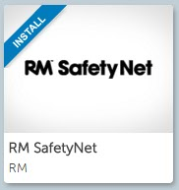

1. Click on the RM SafetyNet tile and an information page for the app is displayed. This includes a privacy statement, which you will need to agree to if you want use the App.

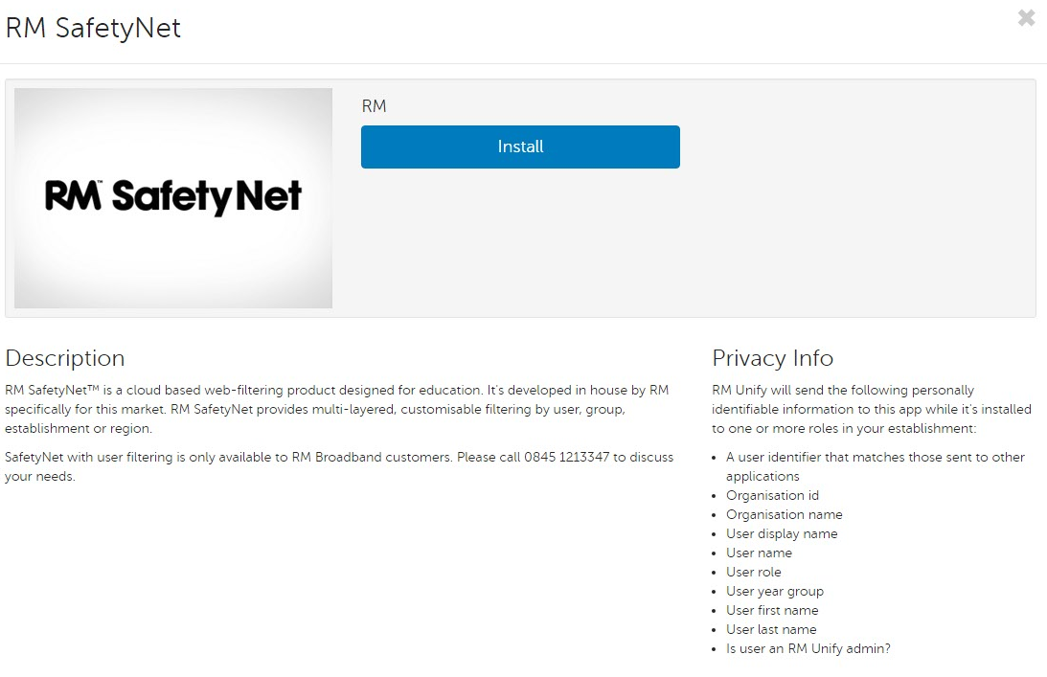

1. To proceed, click **Install**.
2. On the next page, click the **I agree to the privacy statement….** check box at the top of the screen.
3. You now need to continue to set up the RM SafetyNet App. The screen shot below shows you the correct configuration.
   * The RM SafetyNet App should be installed to all roles.
   * The RM SafetyNet App should only appear on the Launch Pad of Non-Teaching Staff.

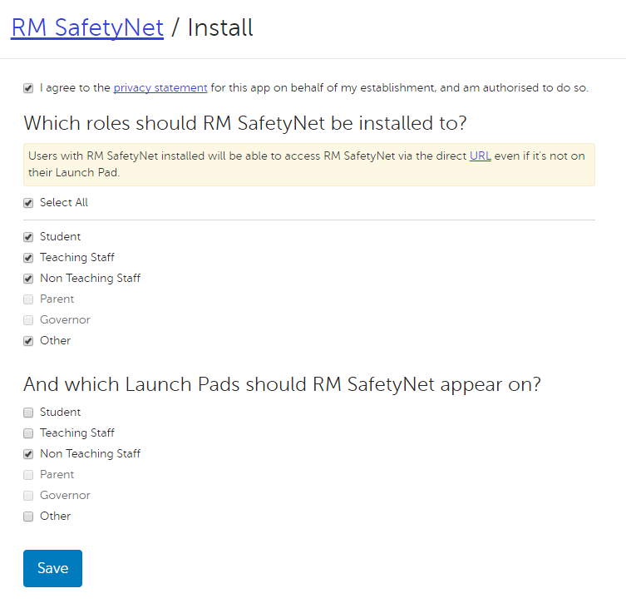

1. Click **Save**.
   * It’s at this point the Users on your Active Directory should be recognised in RM Unify and RM SafetyNet User Based Filtering
2. Close the app information page to return to the App Library.
3. You can now proceed to set up your User Based Filtering Groups and Rules.